- Vision part
  - GoPro Hero4 as the main camera
  - The range is 5-10 meters with drone’s WiFi, up to 40-50 meters (if it wants)
  - Video resolution for now: 432 x 240
  - Camera’s delay is approximately 1 sec
  - Library used - OpenCV
  - The videos stream comes in FFMPEG codec
  - Video is processed on laptop (Intel i5, NVIDIA 640M, 6 GB RAM)
  - cv2.resize if not used (resolution is low already)
  - Trackers:
    - MIL - high FPS, easy to lose target, previous position dependent
    - TLD - resources hungry tracker, but tracks and finds objects rather robustly
    - MEDIANFLOW - great tracking, high FPS, no recovery after losing the object
  - After determining the object, it subtracts the middle point and sends it to the controller computer
    - The tracker makes a bounding box
    - The tracked point is the centre of bounding box
  - Communication between computers is organized via cable using socket
- Control part
  - General
    - The drone flies only outdoors (does not arm indoors in any mode)
    - The computer control mode is GUIDED only
    - Libraries used - dronekit, mavlink
    - Control computer connects with the joystick via WiFI
      - Protocol for connection - UDP
    - Joystick receives commands and send control to quadrotor
  - Controller computer implements keyboard control
    - simple_takeoff and landing mode work clearly
    - YAW and VELOCITY(X,Y,Z) work by compass only
      - if X>0 - quad goes North
      - if X<0 - quad goes South
      - if Y>0 - quad goes EAST
      - if Y<0 - quad goes West
    - Implemented relative positioning using projections (details in another doc)
    - Implemented YAW using mutable state
    - Library for keyboard listening - pynput
  - Controller computer implements tracking control
    - The drone tries to hold the tracked object in the middle
    - The holding is implemented with VELOCITY(X,Y,Z) function, where X,Y are projections to coordinates (do not forget that drone is positioned by compass!)
    - The velocity is raised proportionally according the distance between center of view and the tracked object
      - The set maximum speed depends on the tracked object maximum speed
  - If the object is lost, drone waits for the manual determining the object
    - The tracker can find the object (TLD, for instance), start tracking the environment (MIL) or stop working/behave indefinitely (MEDIANFLOW)

System overview:

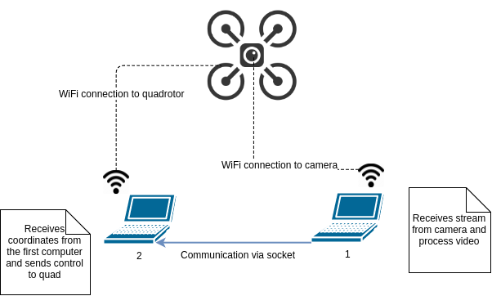

Controller program structure

